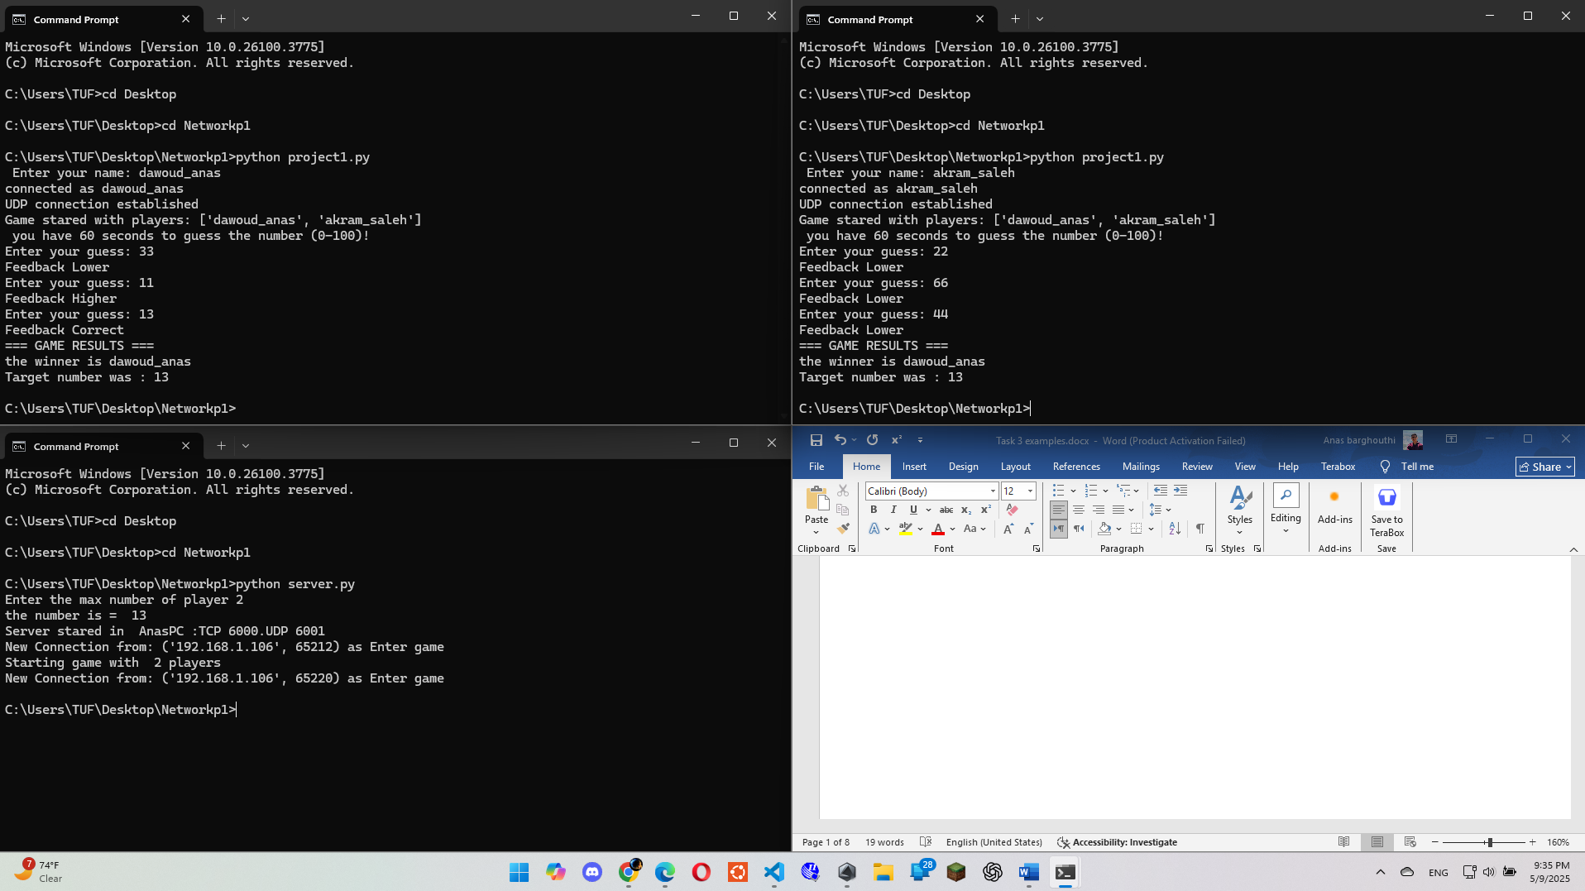

In this case, two clients (players) connect to the server and try to guess the target number, which is 13.  
Each client receives feedback after each guess:

* "Higher" means the guessed number is less than the target.
* "Lower" means the guessed number is greater than the target.

The first player to guess the correct number wins.  
The winner was dawoud_anas!

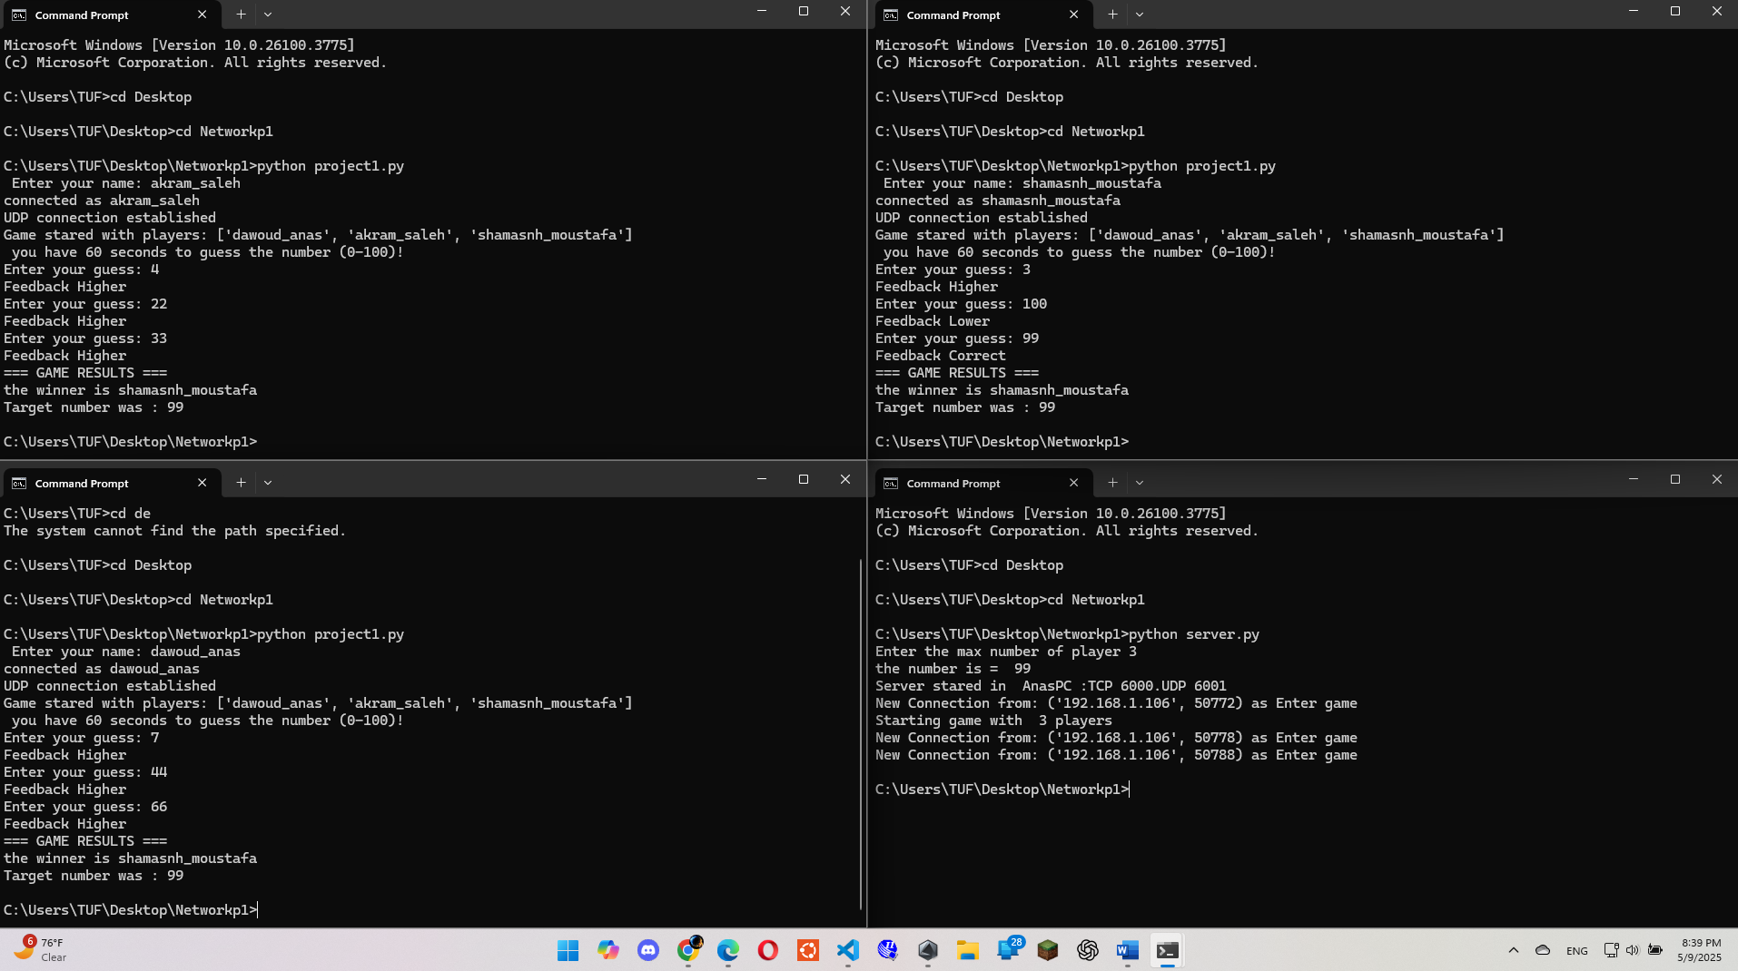

Here there are 3 players enter the server and target number is == 99 ,shamasnh_moustafa won.

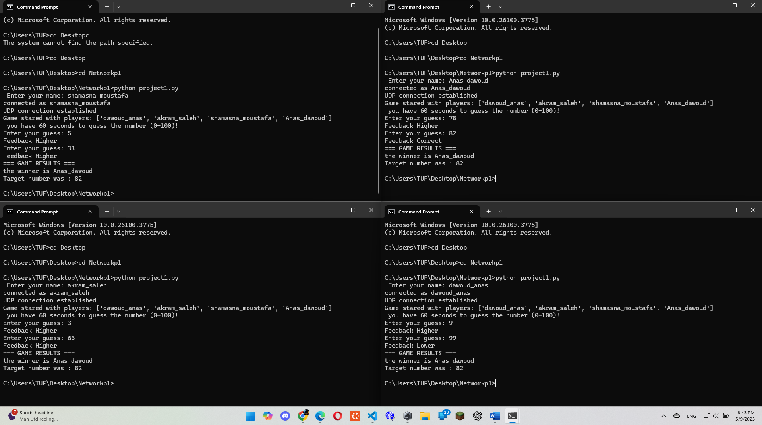

Here there are 3 players enter the server and target number is == 82 , Anas_dawoud won.

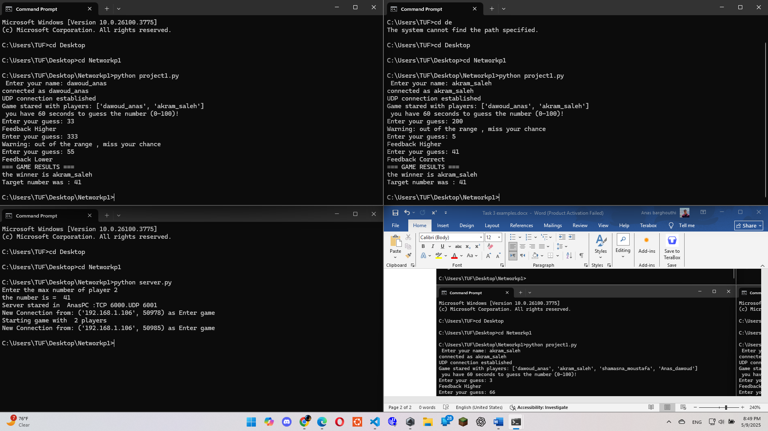

In this case, a client tried to guess a number outside the valid range.  
The server responded by sending a warning message, informing the client that the input was invalid and prompting them to enter a number within the allowed range.

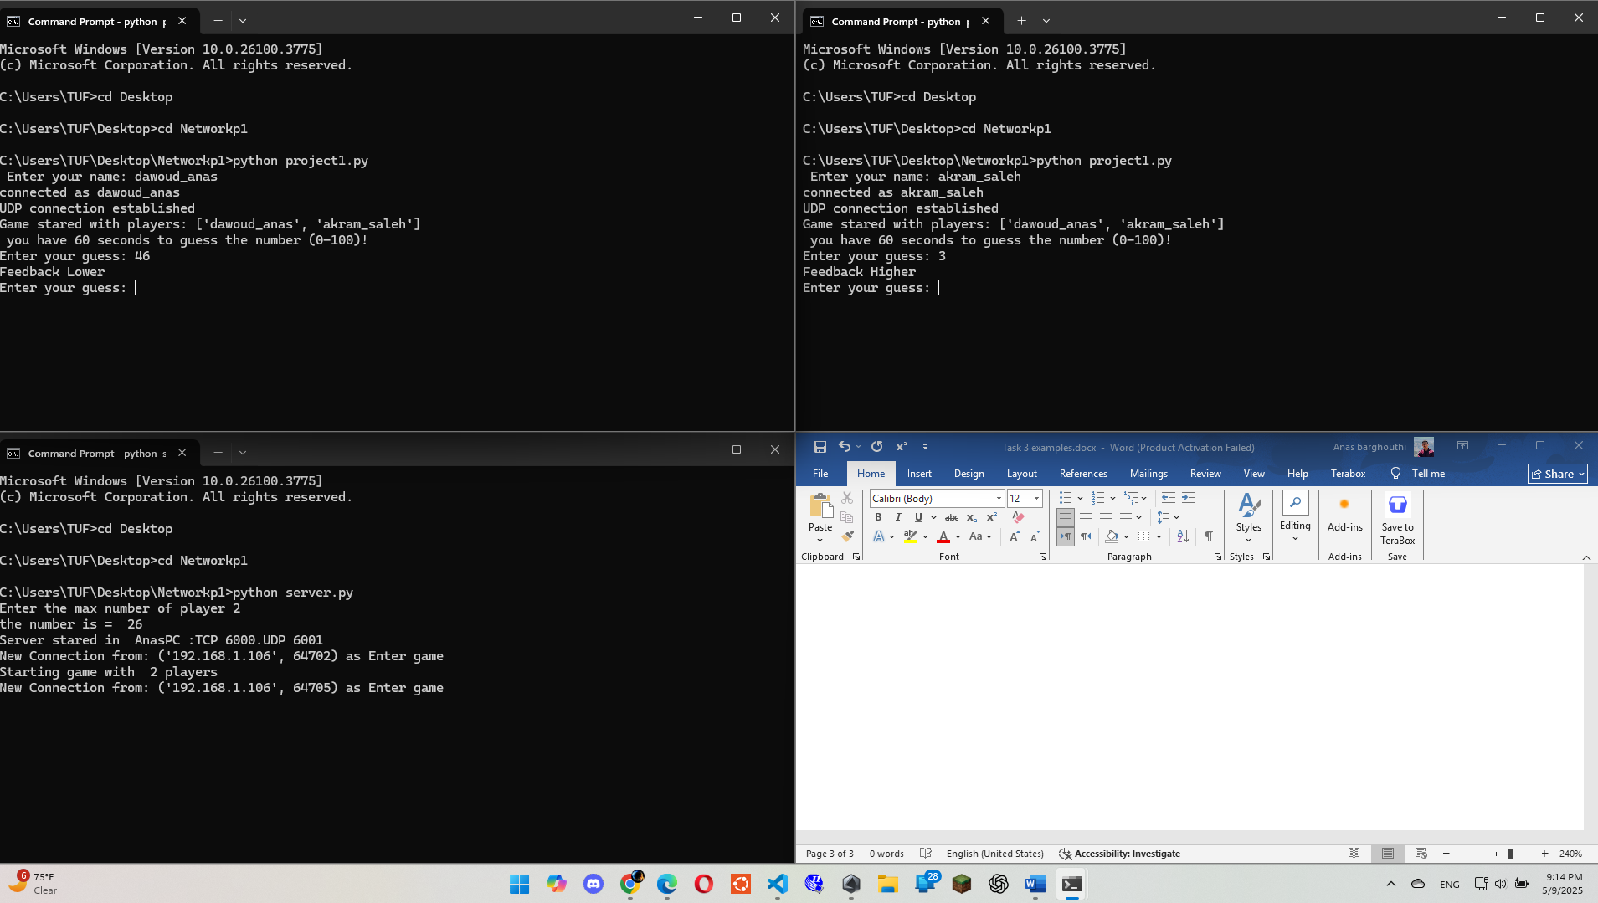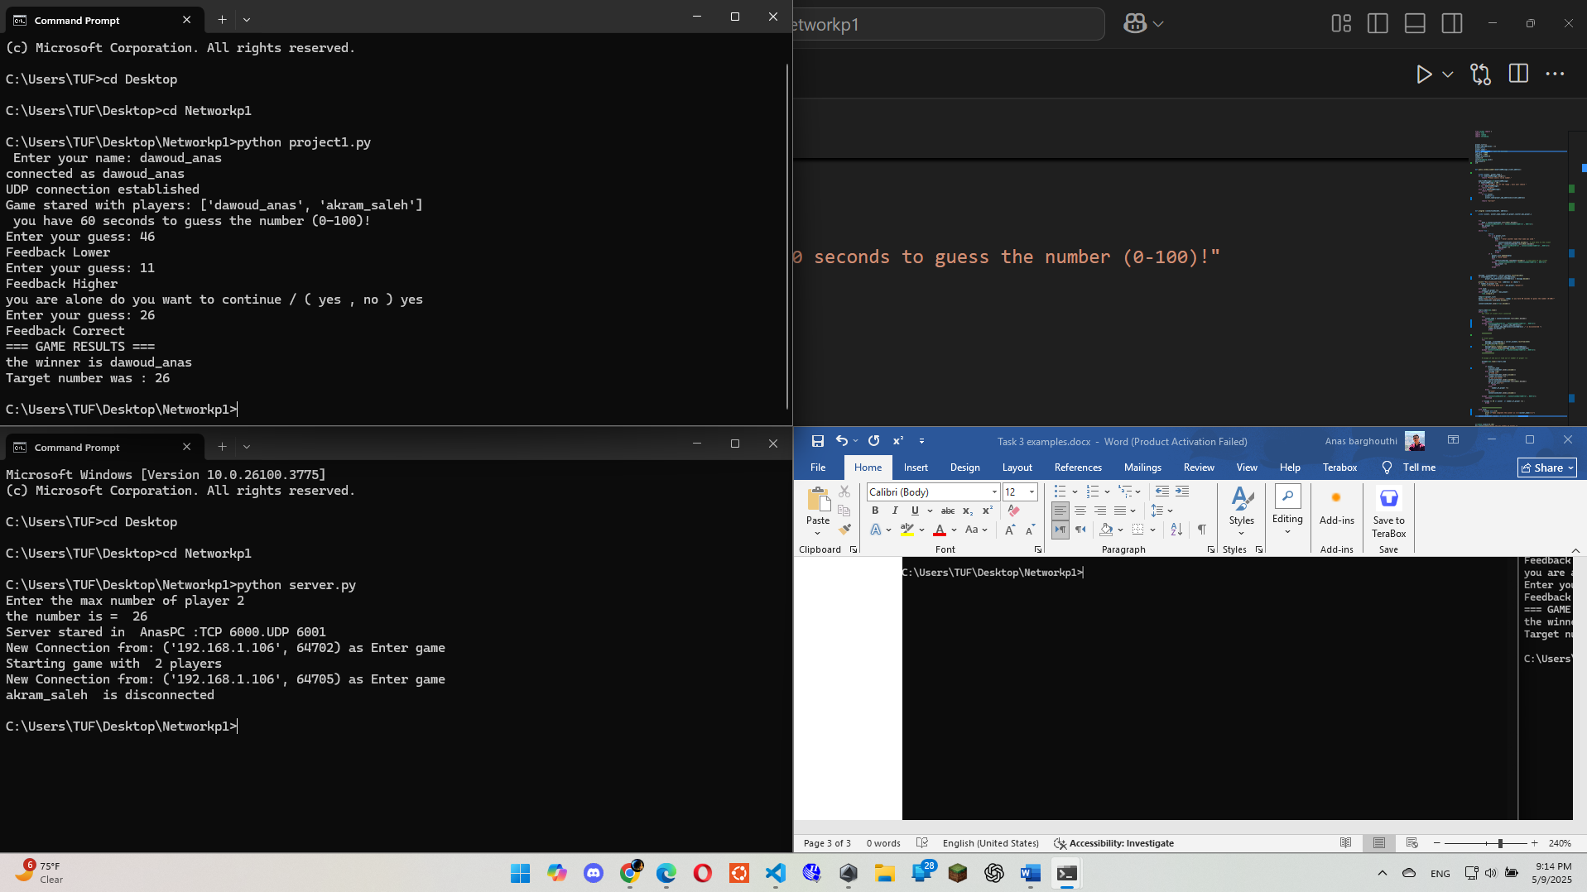

In this case, one of the clients disconnected after he guess.  
Since only one player remained connected to the server, the server presented them with a choice:

* Continue playing
* Exit the game

The player chose to continue playing, and was declared the winner in this round.

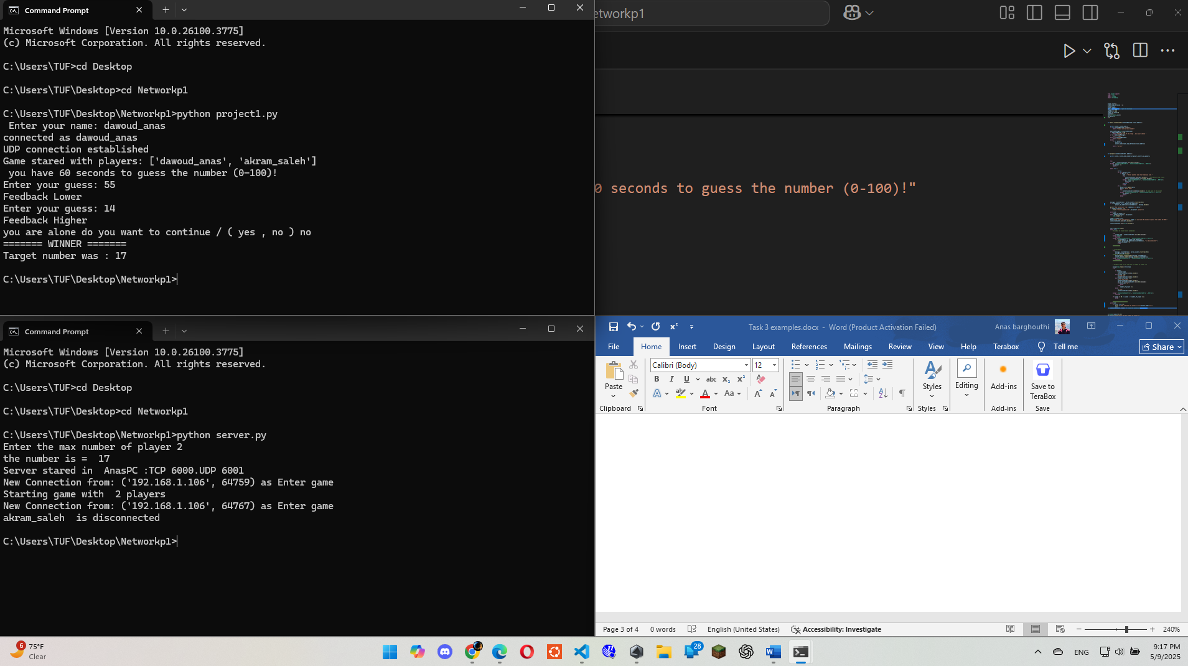

In this case, the same situation occurred as before: one of the players disconnected after the target number was guessed.  
With only one player still connected, the server offered them a choice to either continue playing or exit.  
This time, the player chose to exit the game, and the session ended.

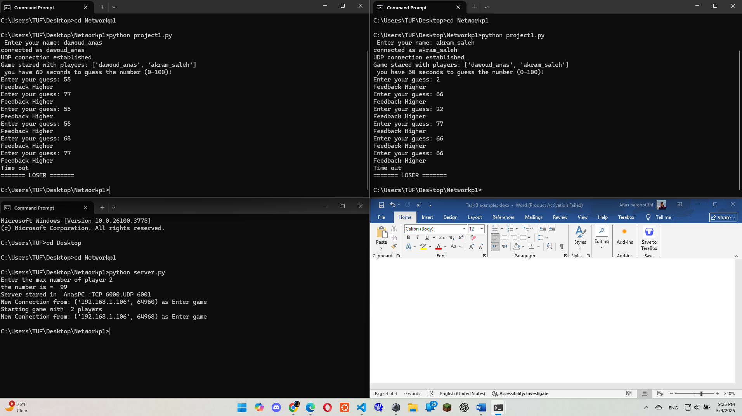

As we know, one round in this game lasts 60 seconds.  
In this case, the round ended before any of the clients guessed the target number.  
Since no one guessed correctly within the time limit, all players lost the round.

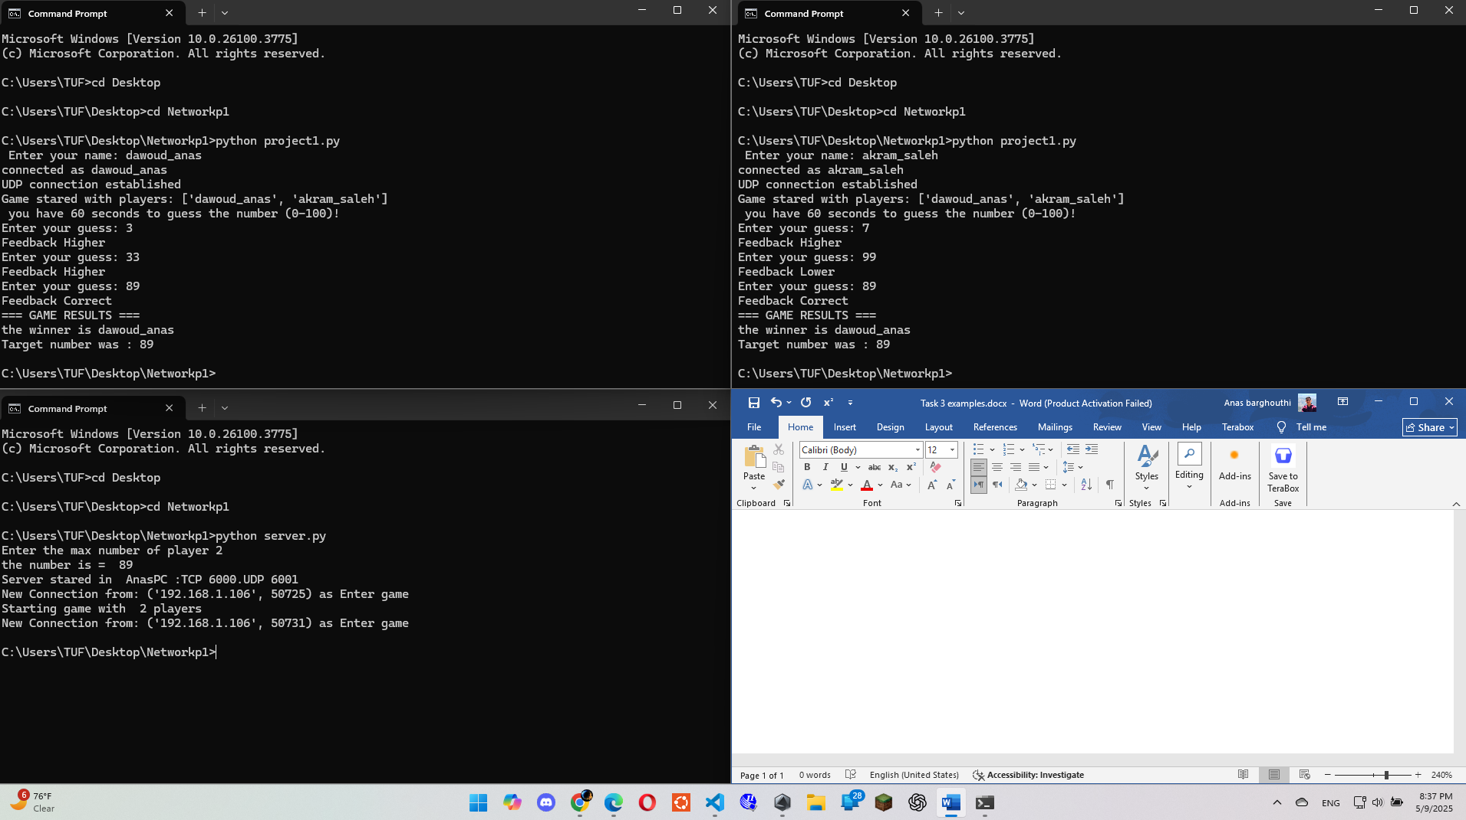

In this case, both players guessed the correct target number, but one of them guessed it before the other.  
According to the game rules, the winner is not just the one who guesses the number, but the one who guesses it first.  
Therefore, the player who made the correct guess earlier was declared the winner of the round.